(Approx. 440 words)

Netiquette: Forwards
Contributed by Melanie Birnbom, Century Village Computer Club, FL
September 2016 Mid-Month Newsletter
www.centuryvillagecomputerclub.com
mbirnbom (at) yahoo.com

It is important to use good manners when forwarding e-mails. Now and again, we all see an interesting message that we might want to share with friends, so we forward it along.

However, other folks practice mass-forwarding. They forward every joke, prayer chain, political e-mail, funny image, urban legend or anything else they can get their hands to everyone they know, including people who are business contacts. That many messages can clog up already full inboxes. It also makes people less likely to notice an actual important e-mail from you. Always avoid sending items like forwards to your friends’ work e-mail addresses. Some examples of emails that should be forwarded using caution are:
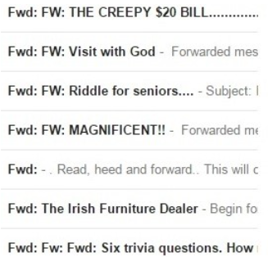

Think back to the days of phone calls and letters. You might call someone up or write them a letter if you saw something interesting, but would you make seven separate phone calls in a day or write seven letters?
One way to be sure you aren’t bombarding your friends is to ask if they want to receive fun forwards or not. But don’t be offended if they say they don’t have the time. Or consider combining the information into one e-mail featuring the best things you’ve seen recently. That takes a little copying and pasting, but a lot of folks actually do that. It’s a convenient way for friends to enjoy things you want to share.
Another considerate thing to do is not to use a “send all” function or go down and select everyone on your list of contacts.
Think carefully about whether or not the person will really be interested. This is also where you can make specific lists of folks to receive jokes or political e-mails after you check with them to see if they are interested.
Social media, such as Facebook, is a great outlet for sharing news stories and jokes. There’s less likelihood of some type of important communication getting buried in a pile or forwards and it was specifically designed for sharing that type of information.
From Judy – Don’t forget to delete all addresses before forwarding any ‘message’ on your joke, etc. e-mail list. If you receive a forwarded joke, etc. with a gazillion e-mail addresses, please let the sender know they should delete all of the addresses before forwarding the message. Tell them Homeland Security, their police department, etc. appreciates them doing that to help reduce people harvesting all of the e-mail addresses and using them for phishing e-mails. They should put the addresses in the Bcc: field.

